2022 N.S.W JUNIOR STATE CUP

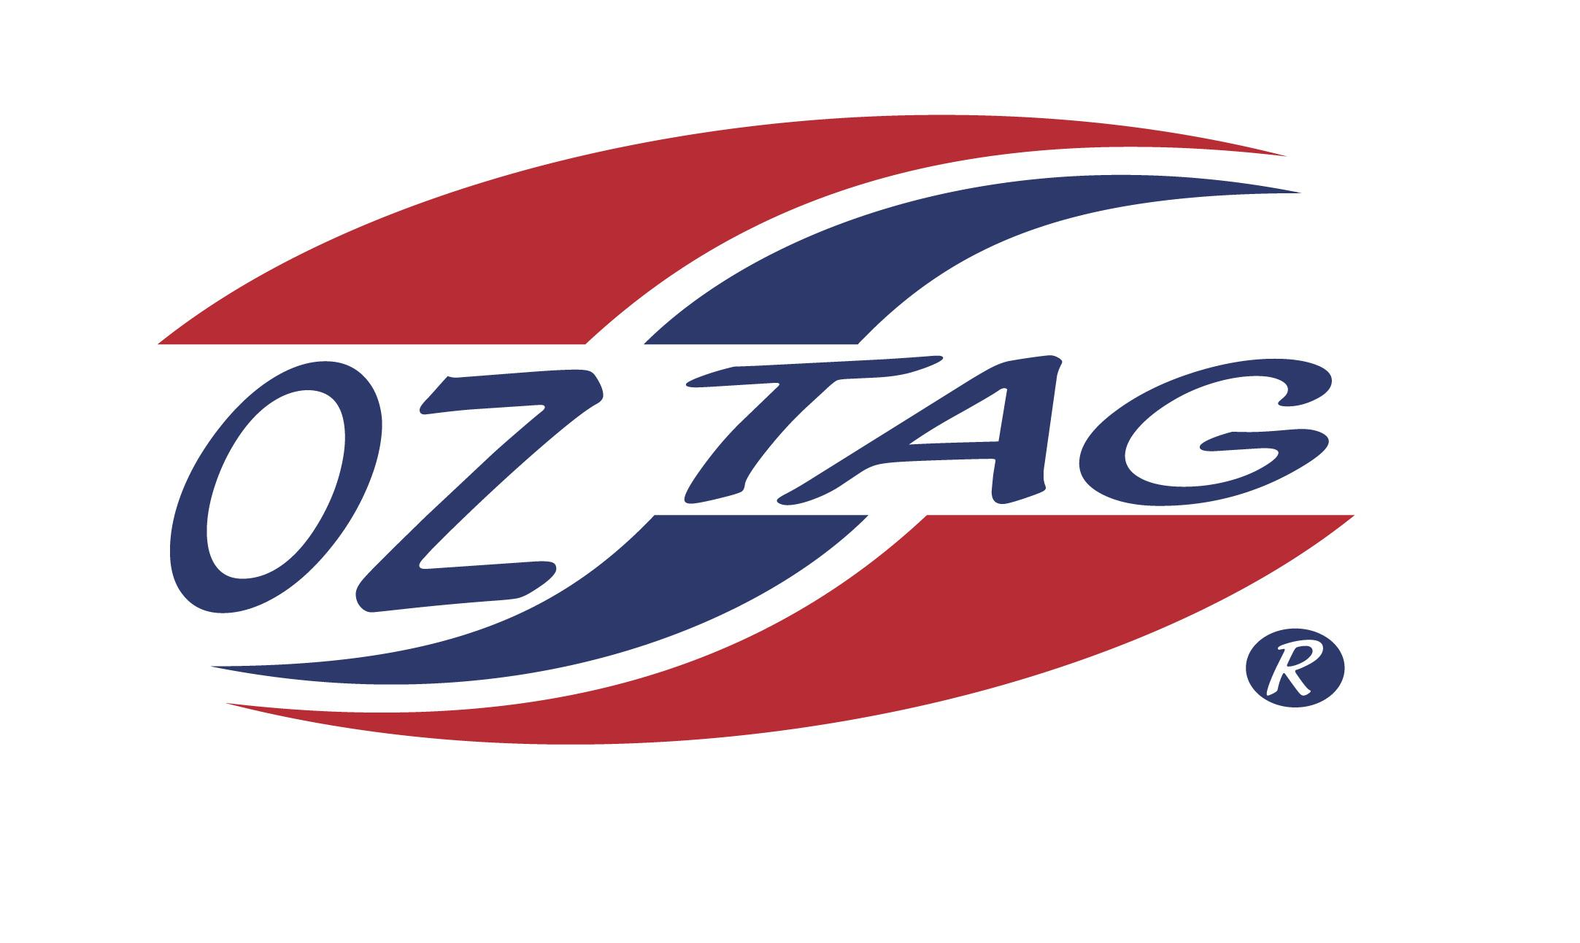
GIRLS 16’S

Coach: ALI MARSH Phone: 0414134206
Email:
Manager: MAINE PAEKAU Phone:0420528051
Email: keianashai@hotmail.com

Congratulations to the following players selected in the East Hills Girls 16’s team to play at the 2022 NSW Junior State Cup – Wed 1st June – Thurs 2nd June, 2022 @ Ce.X Stadium – Coffs Harbour
- Please contact your coach to accept your position in the team and confirm your availability
- Tournament entry is $90 and payable now to your team manager or directly into the East Hills Junior Oztag Account – BSB 032254 – ACC NO 193435 - put your name as the reference

NAME | TEAM
TAYLOR NANGLE | RUN A MUK
MIA SUMMERLAND | THE AMAZONS
MIA CONDOLUCI | THE UNTAGGABLES
ELLA O’DONOVAN | HOLY GUACAMOLE
CHRISSY VARELTSIS | THE AMAZONS
PIA CHRISTIANSEN | MUNCHIES
JESSICA MALLIA | RUN A MUK
SIENNA HANRATTY | RUN A MUK
MARIKA MARU-DICKSON | GREEN MACHINES
NATALIA STEPHENS | HOLY GUACAMOLE
ANAHERA PAEKAU | RUN A MUK
KEISHA MARSH | RUN A MUK
SHANEL KAUKURA GREY | GREEN MACHINE
CARLIETTA MA-CHONG | RUN A MUK
BAILEY MA-CHONG | RUN A MUK
HALLE LUM | MUNCHIES
HALLE MCRAE | RUN A MUK

