2022 N.S.W JUNIOR STATE CUP

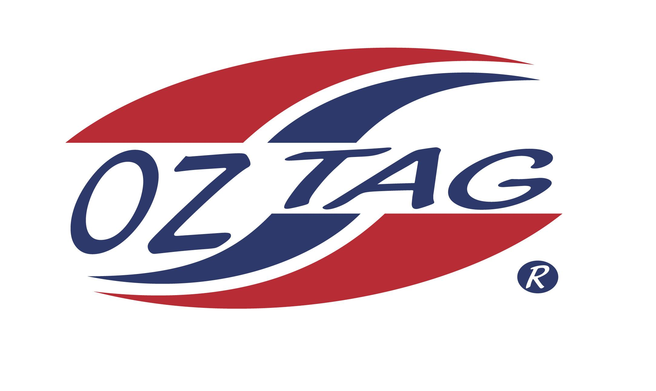
GIRLS 10’S

Coach: Tuck King Phone: 0410570719
Email: tuck_king_32@yahoo.com.au
Manager: Kimberlee King Phone: 0404831373
Email: tanemakaya@hotmail.com

Congratulations to the following players selected in the East Hills Girls 10’s team to play at the 2022 NSW Junior State Cup – Sat 4th – Sun 5th June, 2022 @ Ce.X Stadium – Coffs Harbour
- Please contact your coach to accept your position in the team and confirm your availability
- Tournament entry is $90 and payable now to your team manager or directly into the East Hills Junior Oztag Account- BSB 032254 ACC NO 193435 – put your name as the reference

NAME | TEAM
ANNABELLE SAMPSON | SPOT ON
RUBY CADDY | ME AND MY TAGGERS
CHARLIZE PARKER | SPOT ON
MARIYAH KING | SPOT ON
HAZEL WATTERS | SPOT ON
ALEXANDRA HATTON | NINJA KIDS
LEXI WARING | MERMAIDS
LEIKA GOW | NINJA KIDS
MACYNNE STEEL | SPOT ON
TAMSIN GILLESPIE | MERMAIDS
GISELLE MITCHELL | RED FROGS
MACKENNA KING | SPOT ON
DEMI CLELLAND | RED FROGS
LYLA BARNES | TINY TRAITORS
HALLIE CRAIG | TINY TRAITORS
FARAH JAMES | TINY TRAITORS
SHADOWS  MILLI PICKERING | AWESOME TAGGERS
MADISYN KING | SPOT ON

