2022 N.S.W JUNIOR STATE CUP

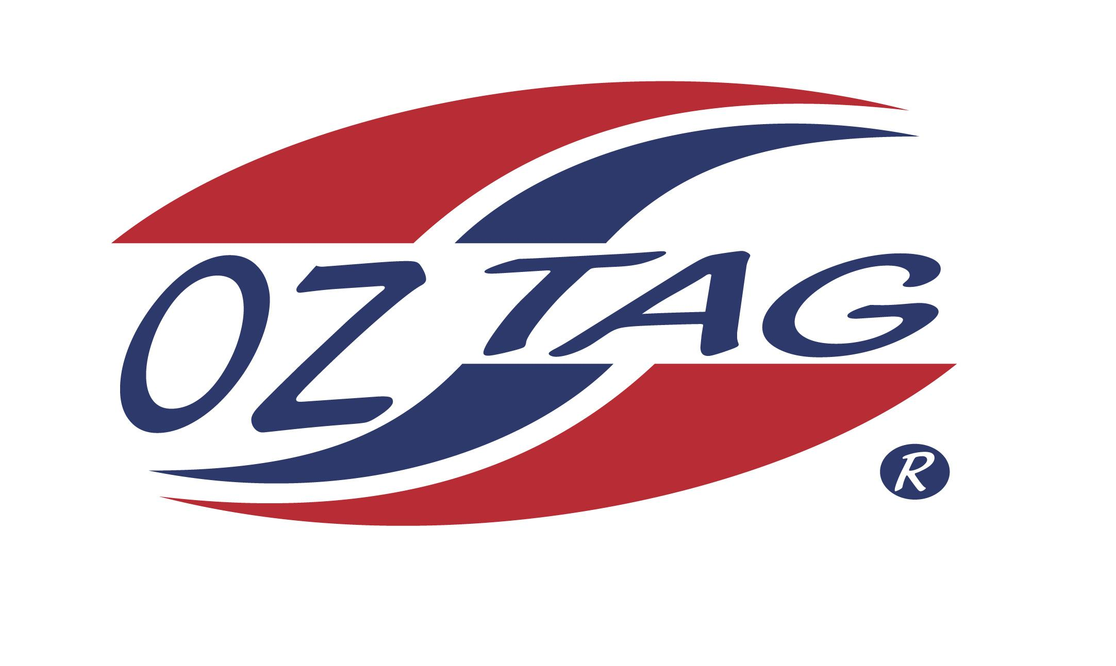
BOYS 9’S

Coach: Corey Brown Phone:
Email:
Manager: Jessica Scott Phone: 0402829346
Email: jessica_751@outlook.com

Congratulations to the following players selected in the East Hills Boys 9’s team to play at the 2022 NSW Junior State Cup – Sat 4th and Sun 5th June, 2022 at Ce.X Stadium Coffs Harbour
- Please contact your manager to accept your position in the team and confirm your availability
- Tournament entry is $90 and payable now to your team manager or directly into the East Hills Junior Oztag Account – BSB 032254 – ACC NO 193435 - put your name as the reference

NAME | TEAM
ISAAC AAD | TAG HUNTERS
KAISON BROWN | TAG HUNTERS
AODHAN O’BRIEN | BEAT THE WILDS
HARLAN POLLARD | LITTLE RIPPERS
JACK WILLIAMS | TINY TRAITORS
LACHLAN MCSHANE | TINY TRAITORS
FINN WARDMAN | THE TAGGOS
KYE FENWICK | NINJA KIDS
THOMAS LARSEN | THE AVENGERS
LENNOX BERRY | COLTIES
XAVIER BATES | FIERCE TIGERS
MANSOUR JUNIOR ARDATI | SHARKS 2
OSMAND FAYAD | SHARKS 2
JACOB ARNAOUT | SHARKS 2
KHALED YAGHI | SHARKS 2
CAYDEN WINTERSTEIN | TAG HUNTERS

