2022 N.S.W JUNIOR STATE CUP

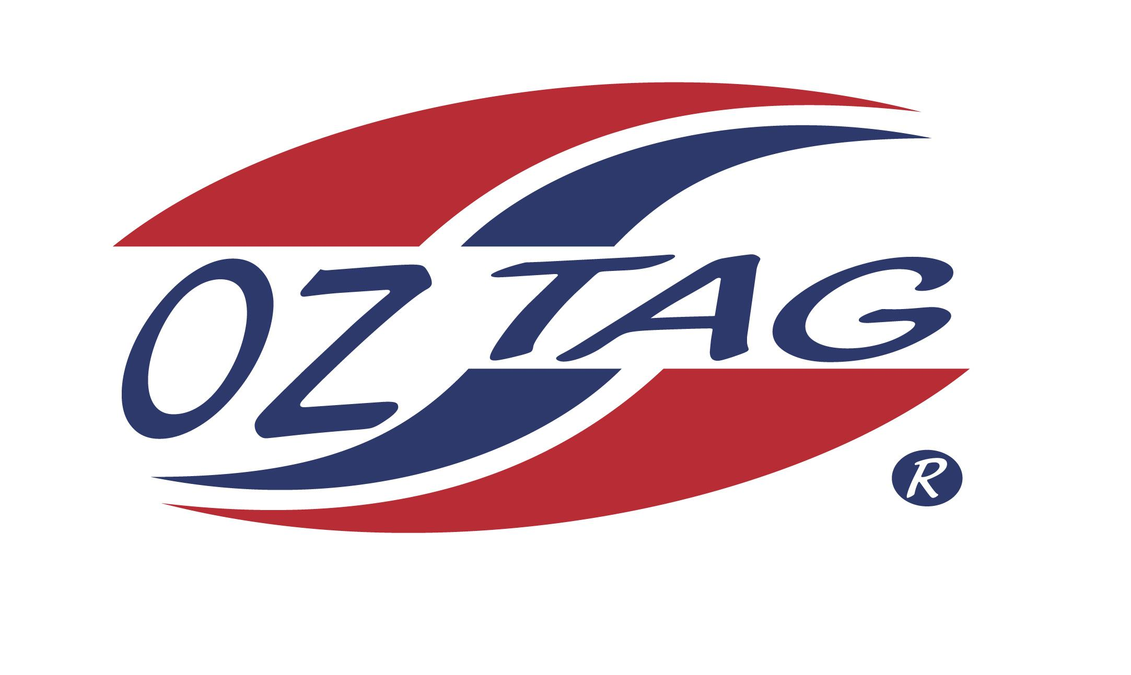
BOYS 13’S

Coach: Stephen Crawford Phone:
Email:
Manager: Roxanne McDonald Phone: 0416187980
Email: threeboysonegirl1982@gmail.com
Ass Coach: Luke

Congratulations to the following players selected in the East Hills Boys 13’s team to play at the 2022 NSW Junior State Cup – Wed 1st – Thurs 2nd June, 2022 - Ce.X Stadium Coffs Harbour
- Please contact your coach to accept your position in the team and confirm your availability
- Tournament entry is $90 and payable now to your team manager or directly into the East Hills Junior Oztag Account – BSB 032254 – ACC NO 193435 -put your name as the reference

NAME | TEAM
MICHAEL CONDOLUCI | MILPY BOYS
ASHTON MACDONALD | MILPY BOYS
CALEB MITCHELL | YEAH THE BOYS
DYLAN THOMPSON | MAD BLOKES
KYLE EBBS | MILPY BOYS
TODD WARDMAN | NINJAS UP
TAISON KING | MILPY BOYS
OSCAR HOOPER | NINJAS UP
NASH MCLELLAN | YEAH THE BOYS
BLAKE PETROVSKI | MILPY BOYS
JYE CONLAN | NINJAS UP
JAKE DODD | FTB
JACKSON VAJDEVSKI | YEAH THE BOYS
CAMERON BEYNON | MILPY BOYS

