2022 N.S.W JUNIOR STATE CUP

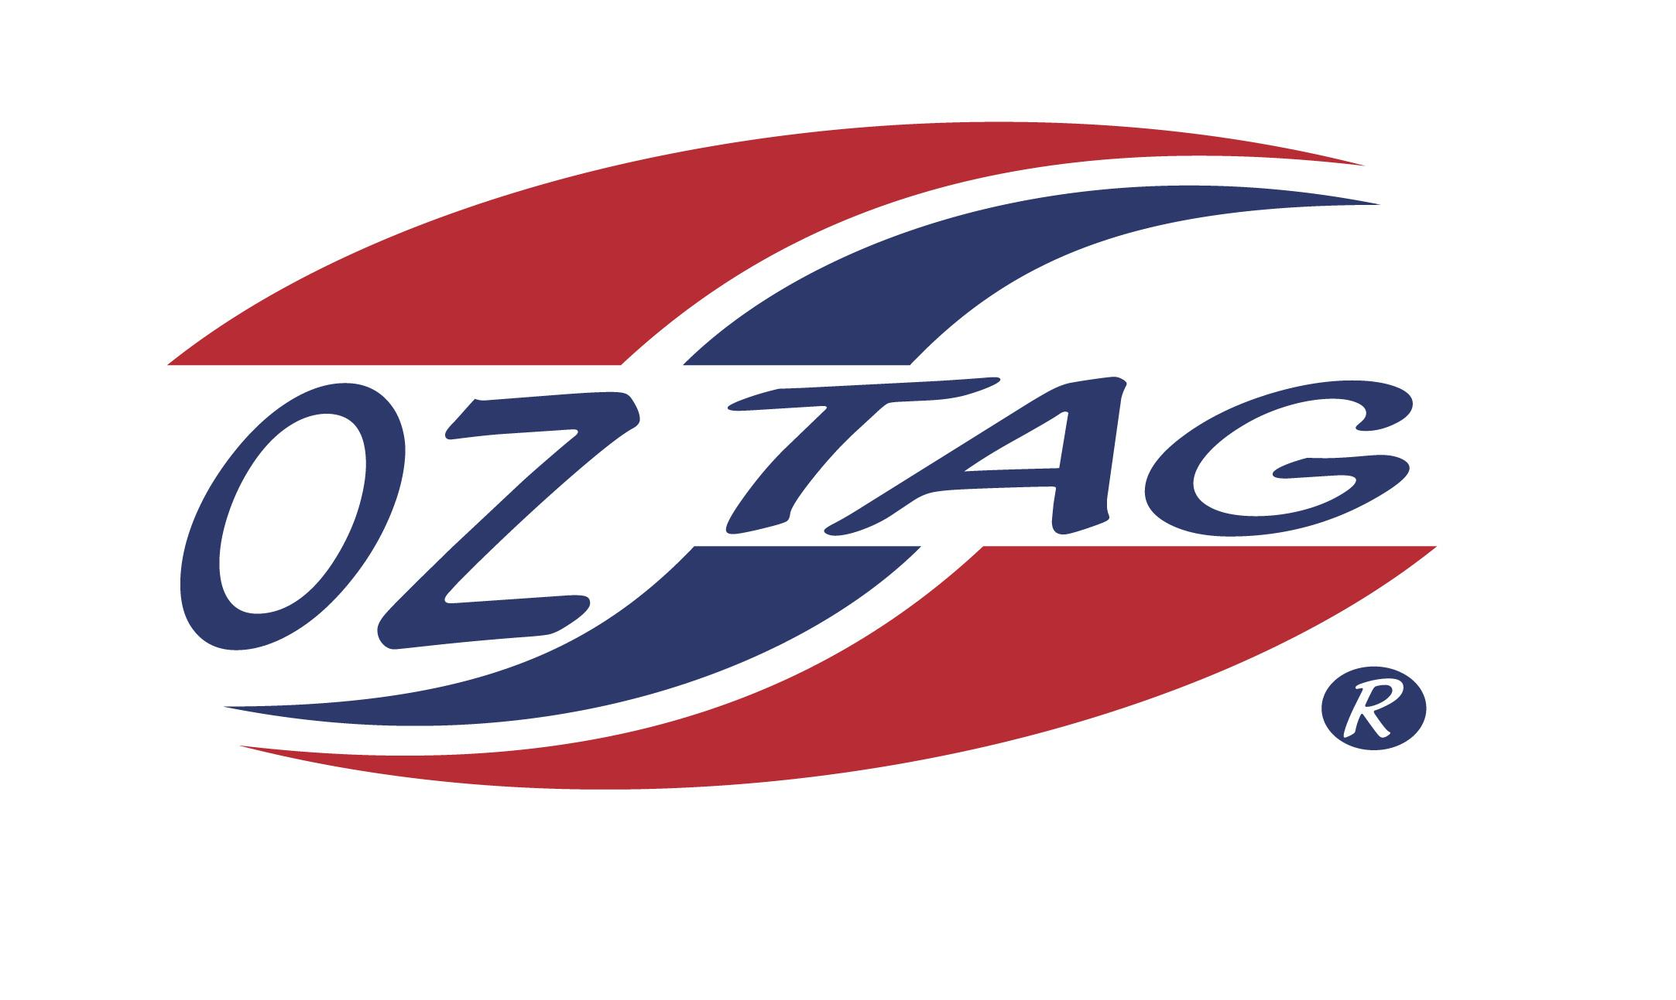
BOYS 12’S

Coach: David Curtis Phone: 0416197552
Email: davidjcurtis1@gmail.com
Manager: Todd Heslehurst Phone: 0413258303
Email: todd@saltcollective.com

Congratulations to the following players selected in the East Hills Boys 12’s team to play at the 2022 NSW Junior State Cup – Sat 4th and Sun 5th June, 2022 @ Ce.X Stadium Coffs Harbour
- Please contact your coach to accept your position in the team and confirm your availability
- Tournament entry is $90 and payable now to your team manager or directly into the East Hills Junior Oztag Account – BSB 032254 – ACC NO 193435 - put your name as the reference

NAME | TEAM
GIBSON TAKU | CASHED
LUKE CURTIS | JUNIOR JETS
HARRY HESLEHURST | JUNIOR JETS
CALLUM CLASPER | FTB
DAMON BEARD | FTB
LOGAN TOWERS | MILPY BOYS
PATRICK PASSARELLI | WILDCATS
DAIN CHRISTIANSEN | WILDCATS
JARRYD TRICKER | JUNIOR JETS
MASON MALLIA | JUNIOR JETS
FLYNN MANA’A | CASHED
DONTAE SIOFELE | CASHED
CALI MOON | CASHED
PETER MARE | YEAH THE BOYS
BRANDON LEAENO | CASHED
SETH OBEREIGNER | JUNIOR JETS

