2022 N.S.W JUNIOR STATE CUP

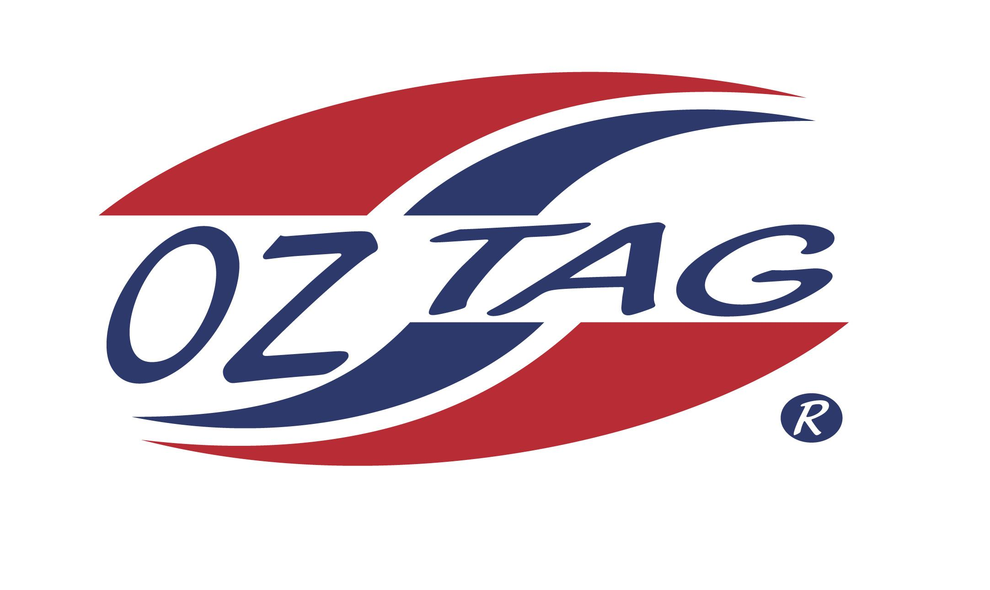
BOYS 10’S

Coach: Greg Payne Phone: 0415887746
Email:
Manager: Vanessa Walsh Phone: 0432431363
Email: vanessachami@yahoo.com.au
Trainer:

Congratulations to the following players selected in the East Hills Boys 10’s team to play at the 2022 NSW Junior State Cup – Sat 4th and Sun 5th June, 2022 at Ce.X Stadium Coffs Harbour
- Please contact your manager to accept your position in the team and confirm your availability
- Tournament entry is $90 and payable now to your team manager or directly into the East Hills Junior Oztag Account – BSB 032254 – ACC NO 193435 - put your name as the reference

NAME | TEAM
BEN MOTU LOUREY | AWESOME TAGGERS
BENJAMIN BRACKEN | THE LIONS
DEXTER PHILLIPS | ME AND MY TAGGERS
JACK ARCHER | AWESOME TAGGERS
JACK COLLEY | TAGGERIFIC
JESSE WALSHE | AWESOME TAGGERS
JOE ELIAS | AWESOME TAGGERS
KYUUS THAN | THE LIONS
MASON AZHAR | AWESOME TAGGERS
NICHOLAS MACE | THE LIONS
BRAX SHERWIN | ME AND MY TAGGERS
WILLIAM HOOPER | THE AVENGERS
BRAYDON MAIMONE | ME AND MY TAGGERS
HARRY ROSS | TAGGERIFIC

