2021 N.S.W JUNIOR STATE CUP

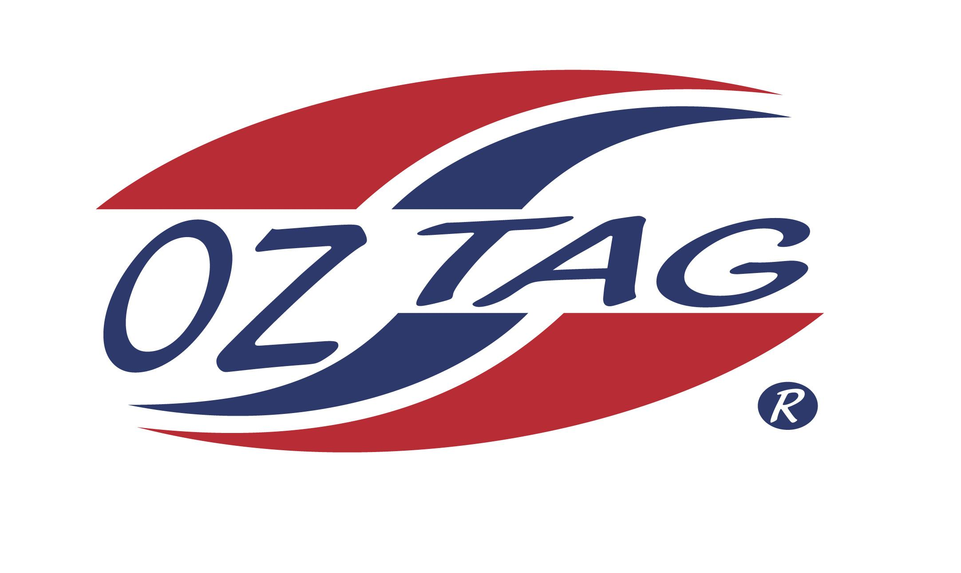
GIRLS 9’S

Coach: Tuck King Phone: 0410570719
Email: tuck_king_32@yahoo.com.au
Manager: Kimberlee King Phone: 0404831373
Email: tanemakaya@hotmail.com

Congratulations to the following players selected in the East Hills Girls 9’s team to play at the 2021 NSW Junior State Cup – Feb 26 – 28, 2021 - The Crest, Bass Hill
- Please contact your coach to accept your position in the team and confirm your availability
- Tournament entry is $90 and payable now to your team manager or directly into the East Hills Junior Oztag Account – put your name as the reference
Uniform is the same as last year – please let your manager know your sizes

NAME | TEAM
MIAH MAARBANI | RED FROGS
ALEXANDRA HATTON | NINJA KIDS
MILLI PICKERING | AWESOME TAGGERS
PHOENIX PRICE-TAIMANA | GREEN MACHINE
CHARLIZE PARKER | RASCALS
LEXIE WARING | THE MERMAIDS
MACYNNE STEEL | THE MERMAIDS
MARIE TAYLOR-MOON | THE MERMAIDS
IRIANA TOHILIMA- GARDINER | WILD ONES
EDEN ROSS | ME AND MY TAGGERS
HAZEL WATTERS | RED FROGS
LEIKA GOW | NINJA KIDS
ANNABEL SAMPSON | RASCALS
MACKENNA KING | RASCALS
MARIYAH KING | RASCALS
MADISYN KING | RASCALS

