2021 N.S.W JUNIOR STATE CUP

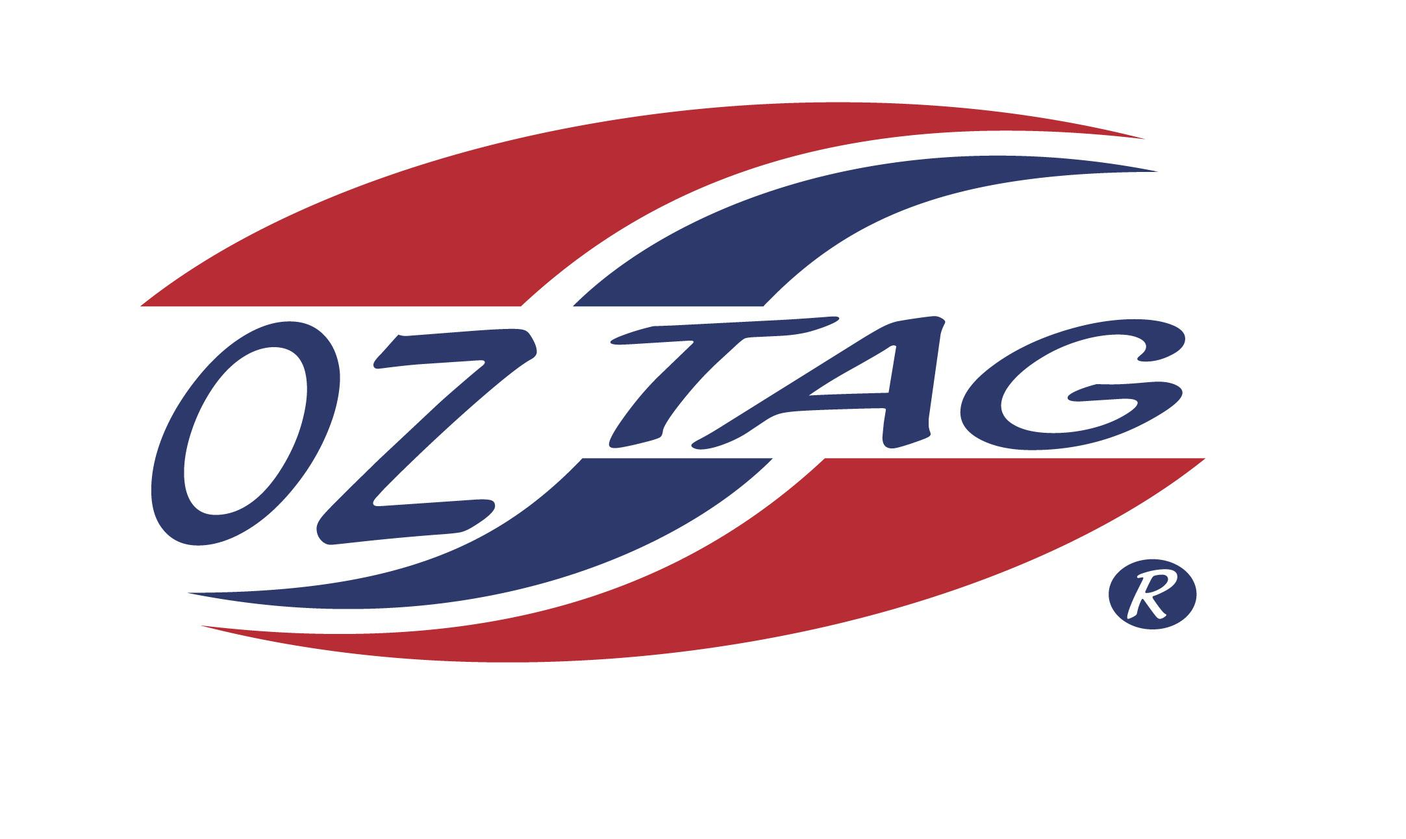
GIRLS 15’S

Coach: Kurt Tatham Phone:
Email:
Manager Laura Phillips Phone: 0421084211
Email: laura.knowles88@hotmail.com

Congratulations to the following players selected in the East Hills Boys 14’s team to play at the 2021 NSW Junior State Cup – Feb 12 – 14, 2021 - Coffs Harbour
- Please contact your coach to accept your position in the team and confirm your availability
- Tournament entry is $90 and payable now to your team manager or directly into the East Hills Junior Oztag Account – put your name as the reference
- Uniform is the same as last year – please let your manager know your sizes

NAME | TEAM
BROOKE PHILLIPS | SAINTS
MARIAH TATHAM | SAINTS
MADISON TOM | SAINTS
ELLA-ROSE WIGHT | SAINTS
ANAHERA PAEKAU | RUN A MUK
CHRISSY VARELTSIS | SAINTS
MIA SUMMERLAND | SAINTS
OLIVIA DAWES | SAINTS
TAYLOR NANGLE | RUN A MUK
MIA CONDOLUCI | SAINTS
ELLA O’DONOVAN | SAINTS
HALLE MCRAE | RUN A MUK
JADE POUND | RUN A MUK

