2021 N.S.W JUNIOR STATE CUP

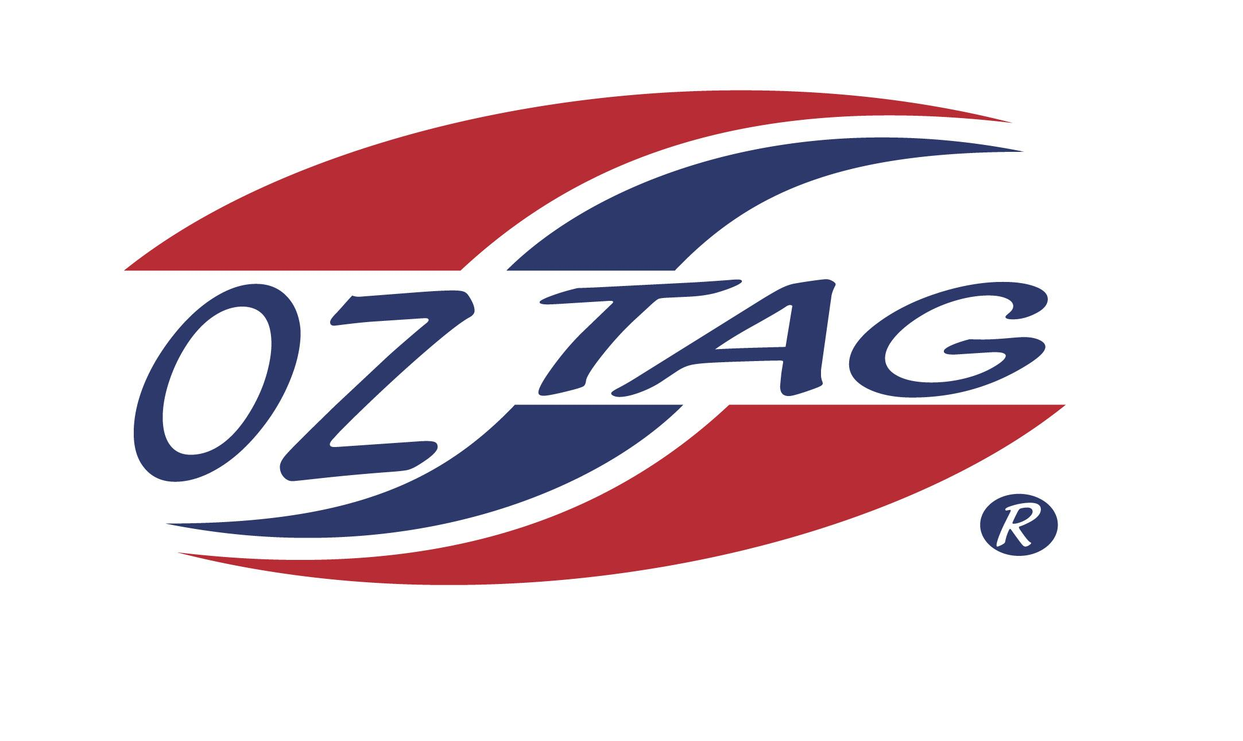
GIRLS 12’S

Coach: Shannon Parker Phone: 0411751169
Email: sparker@assetglobaltransport.com.au
Manager Jessica Gleeson Parker Phone: 0415230145
Email: Jessica_glee@hotmail.com
Ass Coach: Scott Bentley
Ass Coach: Graham Peters

Congratulations to the following players selected in the East Hills Girls 12’s team to play at the 2021 NSW Junior State Cup – Feb 12 – 14, 2021 - Coffs Harbour
- Please contact your coach to accept your position in the team and confirm your availability
- Tournament entry is $90 and payable now to your team manager or directly into the East Hills Junior Oztag Account – put your name as the reference
- Uniform is the same as last year – please let your manager know your sizes

NAME | TEAM
Adele Hayes | Tag Poppettes
Alannah Abouzeid | Drama Queens
Angela Tsamoulos | Da Girls
Ashleigh Peters | Da Girls
Emily Fisher | Da Girls
Emma Phillips | Tag Poppettes
Hadlee James | Da Girls
Hannah Elvin | Da Girls
Kayla Bentley | Da Girls
Ruby Parker | Da Girls
Sarah Cannon | Da Girls
Tilly Fuz | Da Girls
Vivianne Tarabey | Da Girls
Kristy Abouzeid | Georges River Jets
Kayla Pargovski | Da Girls
Rebekah Azar | Georges River Jets

