2021 N.S.W JUNIOR STATE CUP

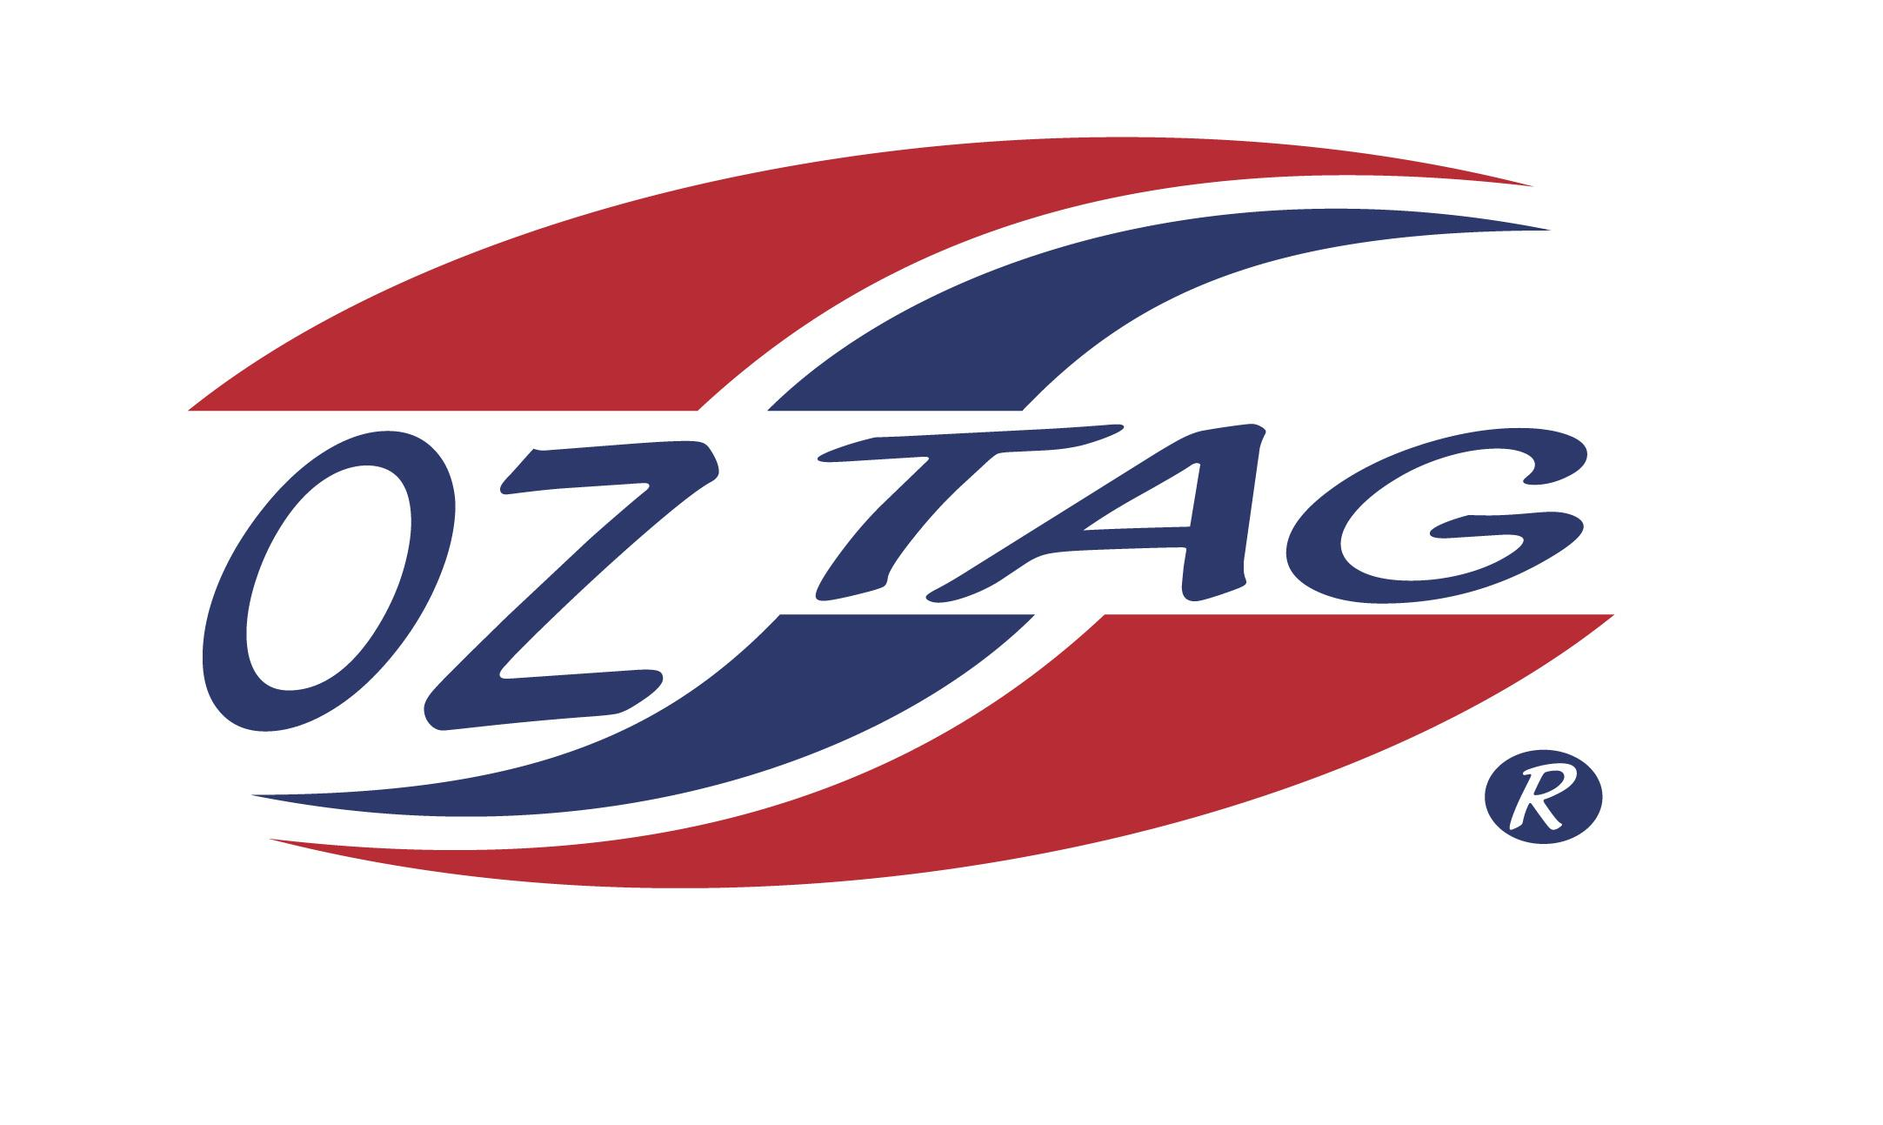
GIRLS 11’S

Coach: Louise Weir Phone: 0417448829
Email: louweir@optusnet.com.au
Manager: Peieta Ace Phone: 0404858715
Email: peieta@hotmail.com

Congratulations to the following players selected in the East Hills Girls 11’s team to play at the 2021 NSW Junior State Cup – Feb 26 – 28, 2021 - The Crest, Bass Hill
- Please contact your coach to accept your position in the team and confirm your availability
- Tournament entry is $90 and payable now to your team manager or directly into the East Hills Junior Oztag Account – put your name as the reference
- Uniform is the same as last year – please let your manager know your sizes

NAME | TEAM
IMOGEN ACE | SASS SQUAD
EDEN ALLIE | SASS SQUAD
SIENNA BENDER | SASS SQUAD
SOFIA D’AGASTINO | SASS SQUAD
JADE DOMINIS | SASS SQUAD
JAYDE FOAT | BABY SHARKS
JORJA HALSE | SASS SQUAD
KHLOE HUNTER | RED BULLETS
RUBY LANE | OZSTARS
CHLOE SHANKAR | SASS SQUAD
HAYLEY WEIR | SASS SQUAD
MARLEY MCRAE | SASS SQUAD

