2021 N.S.W JUNIOR STATE CUP

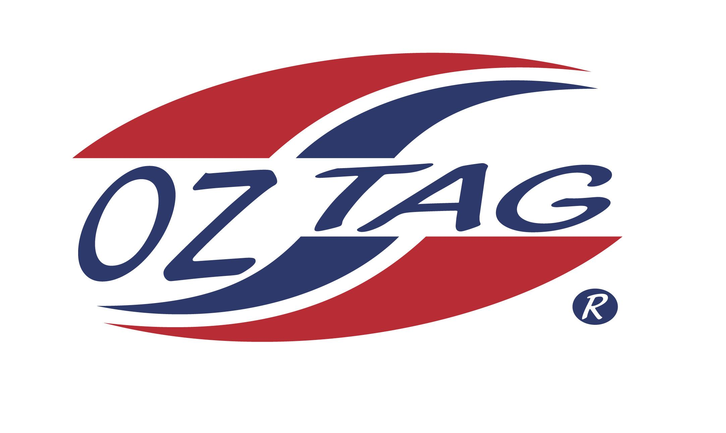
BOYS 9’S

Coach: Greg Payne Phone: 0415887746
Email:
Manager: Vanessa Walsh Phone: 0432431363
Email: vanessachami@yahoo.com.au

Congratulations to the following players selected in the East Hills Boys 9’s team to play at the 2021 NSW Junior State Cup – Feb 26 – 28, 2021 - The Crest, Bass Hill
- Please contact your coach to accept your position in the team and confirm your availability
- Tournament entry is $90 and payable now to your team manager or directly into the East Hills Junior Oztag Account – put your name as the reference
- Uniform is the same as last year – please let your manager know your sizes

NAME | TEAM
JOE ELIAS | AWESOME TAGGERS
ISSAC AAD | RASCALS
WILLIAM HOOPER | THE AVENGERS
JACK ARCHER | AWESOME TAGGERS
KAISON BROWN | RASCALS
JACK COLLEY | TAGGERIFIC
BENJAMIN BRACKEN | THE LIONS
JACKSON CHOW | THE LIONS
HARRY ROSS | TAGGERIFIC
TOMMY BUXTON | AWESOME TAGGERS
OSCAR HOOGENDYK | THE AVENGERS
JESSE WALSHE | AWESOME TAGGERS
DEXTER PHELPS | ME AND MY TAGGERS
KAYDEN WILLIS | THE AVENGERS
BRAX SHERWIN | RASCALS
SHIA DAVENPORT | AWESOME TAGGERS

