2021 N.S.W JUNIOR STATE CUP

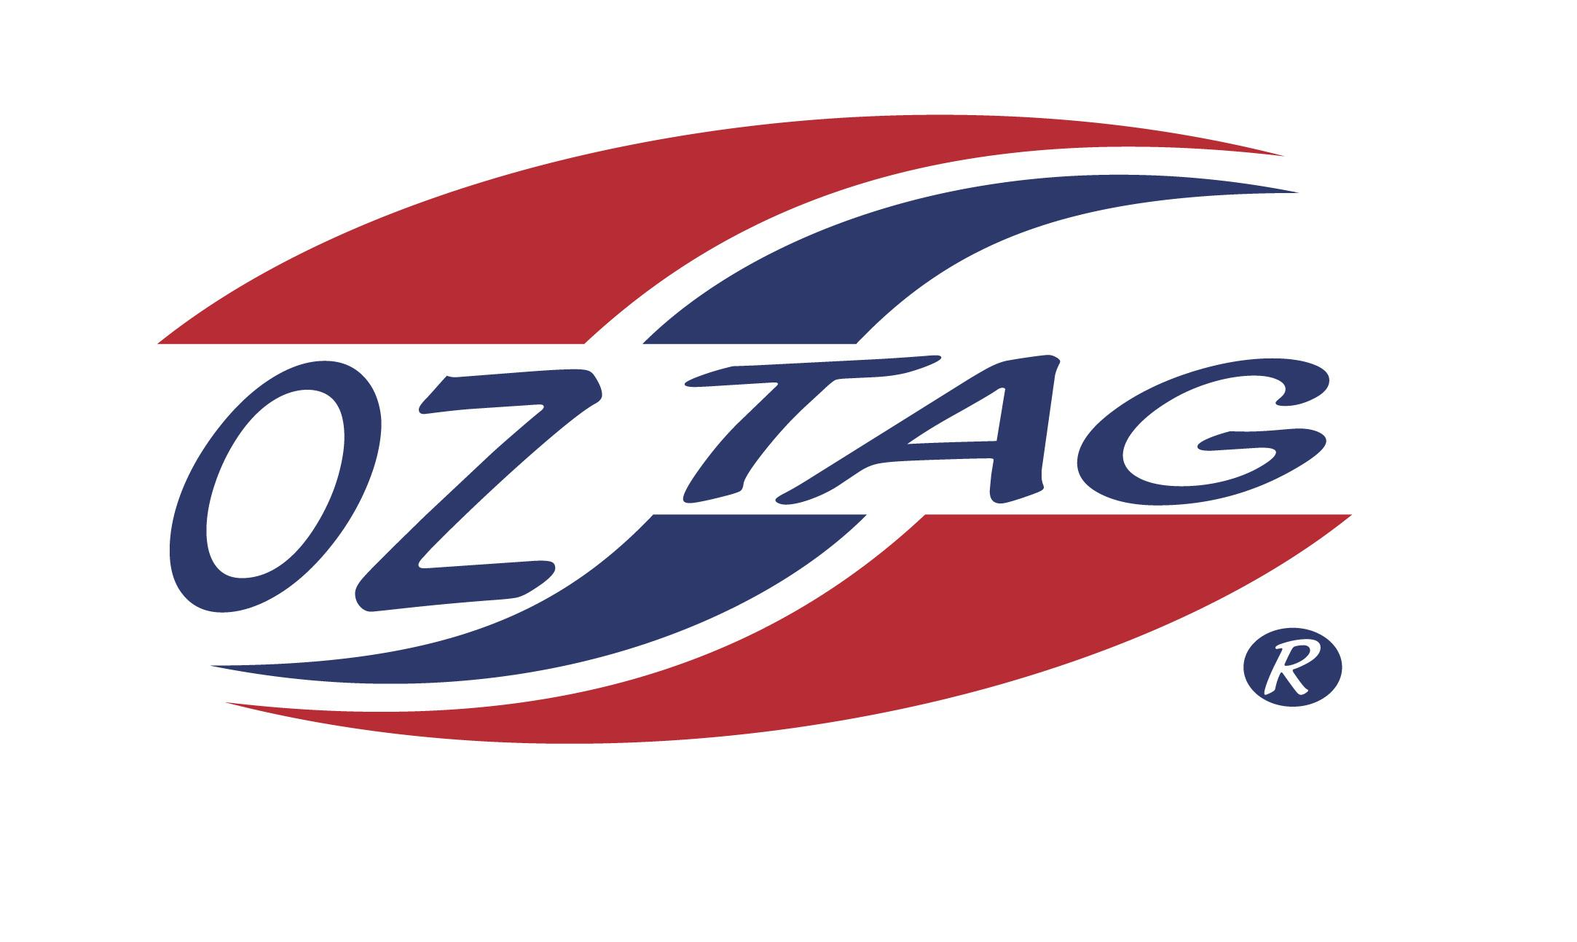
BOYS 17’S

Coach: Jamie Tricker Phone: 0407278290
Email:
Manager: Jacqui Tiberti Phone: 0414495095
Email: davjac1@optusnet.com.au

Congratulations to the following players selected in the East Hills Boys 17’s team to play at the 2021 NSW Junior State Cup – Feb 12 – 14, 2021 - Coffs Harbour
- Please contact your coach to accept your position in the team and confirm your availability
- Tournament entry is $90 and payable now to your team manager or directly into the East Hills Junior Oztag Account – put your name as the reference
- Uniform is the same as last year – please let your manager know your sizes

NAME | TEAM
LUKE BATES | WHY BUT
SEAN BOMBACI | YOU GOODS
VINCENT CASSAR | YOU GOODS
BEAU COLLINS | YOU GOODS
BAILEY FULLER | WHY BUT
LUKE HALLOWES | YOU GOOD
TIM JAGGERS | WHY BUT
HARRY PASSALIS | WHY BUT
ZAC POUND | YOU GOODS
BRENDAN LEECE | YOU GOODS
ZAC SPITTAL | WHY BUT
HAYDEN SWIBEL | YOU GOODS
KEANU TAKI | WHY BUT
JAMES TENCATEN | YOU GOODS
BRAYDEN THICKETT | SLY TAGGERS
DANIEL TIBERTI | YOU GOODS

