2021 N.S.W JUNIOR STATE CUP

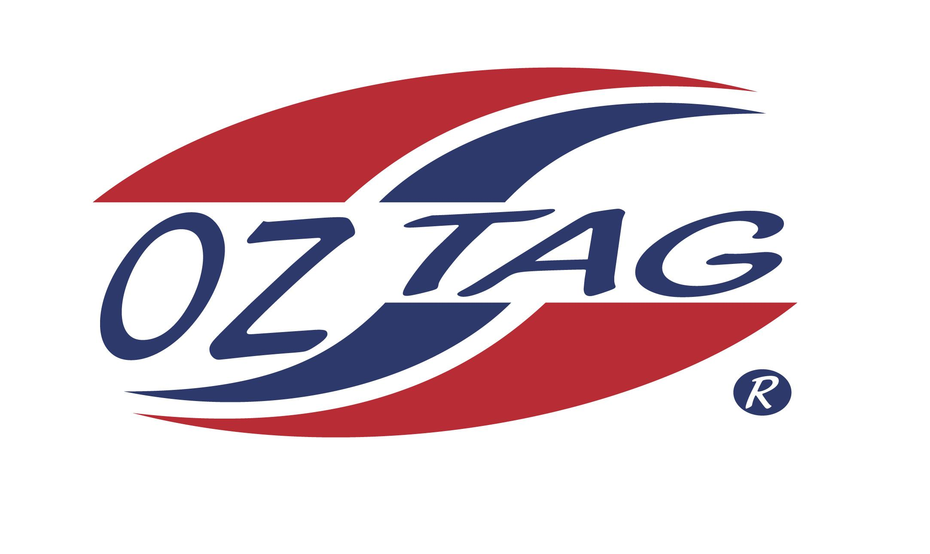
BOYS 14’S

Coach: Todd Barr Phone: 0403585414
Email: tlbcivil@gmail.com
Manager: Louise Weir Phone: 0417448829
Email: louweir@optusnet.com.au

Congratulations to the following players selected in the East Hills Boys 14’s team to play at the 2021 NSW Junior State Cup – Feb 12 – 14, 2021 - Coffs Harbour
- Please contact your coach to accept your position in the team and confirm your availability
- Tournament entry is $90 and payable now to your team manager or directly into the East Hills Junior Oztag Account – put your name as the reference
- Uniform is the same as last year – please let your manager know your sizes

NAME | TEAM
LUKE ABOUZEID | THE JIBBERERS
LUKE TIBERTI | TAG WARRIORS
JAKESIMMONS | TAG WARRIORS
LUCAS PENGUE | SAINTS 14’S
AHMED ASSAD | TAG WARRIORS
COOPER WARD | PINK PELICANS
EDAN WALLACE | TAG WARRIORS
DAUNTE BARR | TAG WARRIORS
NOAH WEIR | TAG WARRIORS
RHYS GITSHAM | TAG WARRIORS
LUCAS GOLOVODOVSKI | TAG WARRIORS
SIMON ZANZOUL | TAG WARRIORS
KOBY COOKE | THE OTHER TEAM
ETHAN RENTON | PINK PELICANS
JAKE BENDER | SAINTS 14’S
MATTHEW HAYEK | TAG WARRIORS

