2021 N.S.W JUNIOR STATE CUP

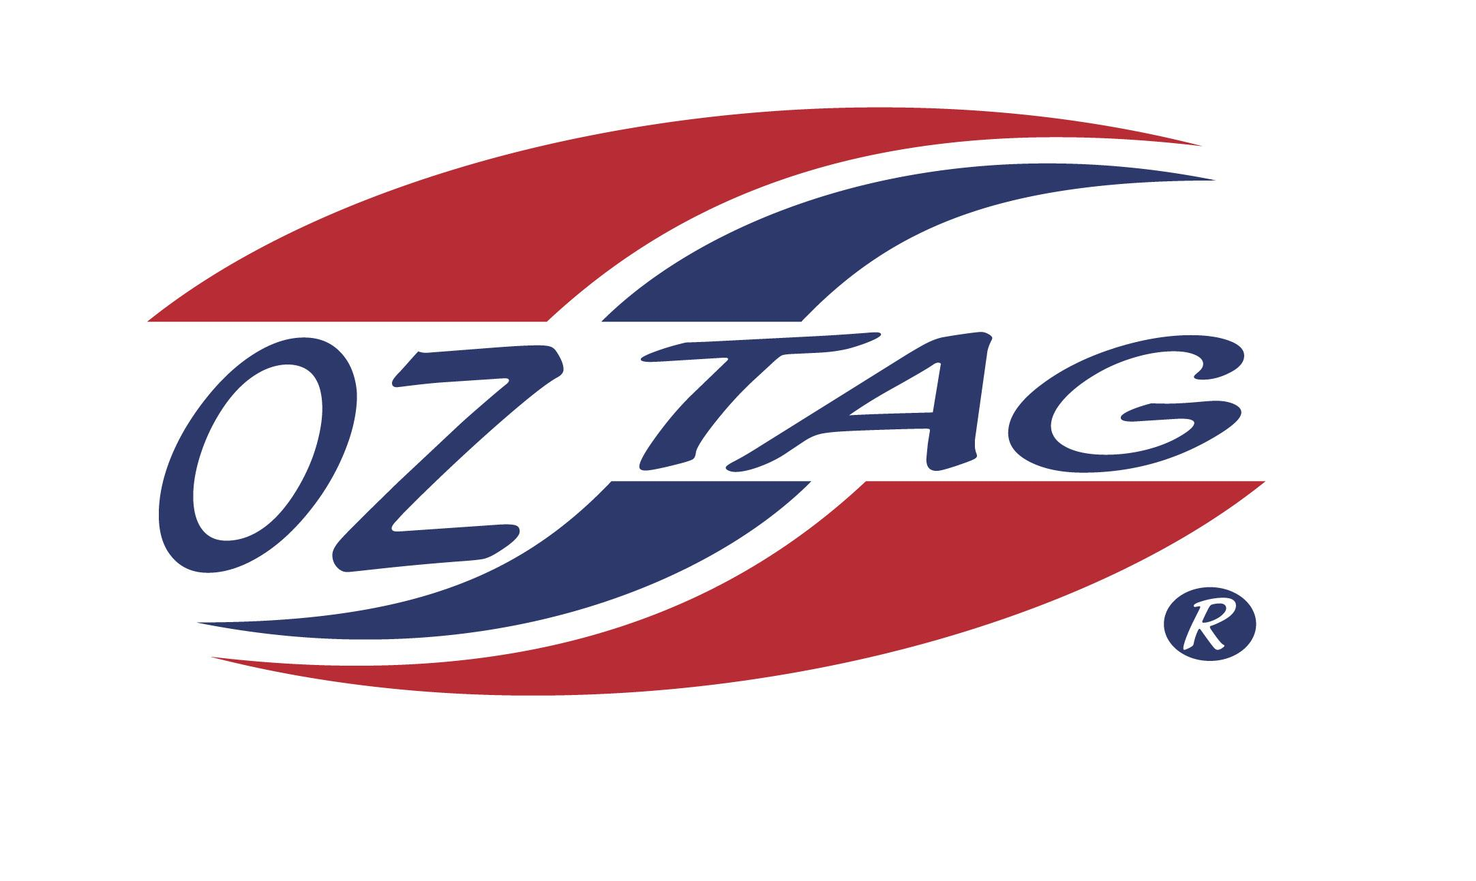
BOYS 13’S

Coach:Joe Sabbagh Phone: 0420979495
Email: becsabbagh@yahoo.com.au
Manager: Bec Sabbagh Phone: 0409746406
Email: becsabbagh@yahoo.com.au
Ass Coach: Joe Hayek Andrew Benson

Congratulations to the following players selected in the East Hills Boys 13’s team to play at the 2021 NSW Junior State Cup – Feb 12 – 14, 2021 - Coffs Harbour
- Please contact your coach to accept your position in the team and confirm your availability
- Tournament entry is $90 and payable now to your team manager or directly into the East Hills Junior Oztag Account – put your name as the reference
- Uniform is the same as last year – please let your manager know your sizes

NAME | TEAM
RHYS PARMETER | ELECTRIFYING
FINN BENSON | SPOT ON
JOSHUA SABBAGH | SPOT ON
DANIEL HAYEK | SPOT ON
COOPER PARKER | SPOT ON
MATT TIBERTI | SPOT ON
TYLER MUNN | CHRISSY’S
HARRY GOURLEY | ELECTRIFYING
XAVIUS WILSON | CHRISSY’S
KOBI JEFFCOAT | SPOT ON
P.J. A’APRILE | LITTLE CHAMPIONS
COOPER WHITE | SPOT ON
JACK CAMPBELL | RIPPED OFF
ADAM WILLIAMS | SPOT ON
ORLANDO GARCIA | SPOT ON
RHYS DEL GRANDE | SPOT ON

