2021 N.S.W JUNIOR STATE CUP

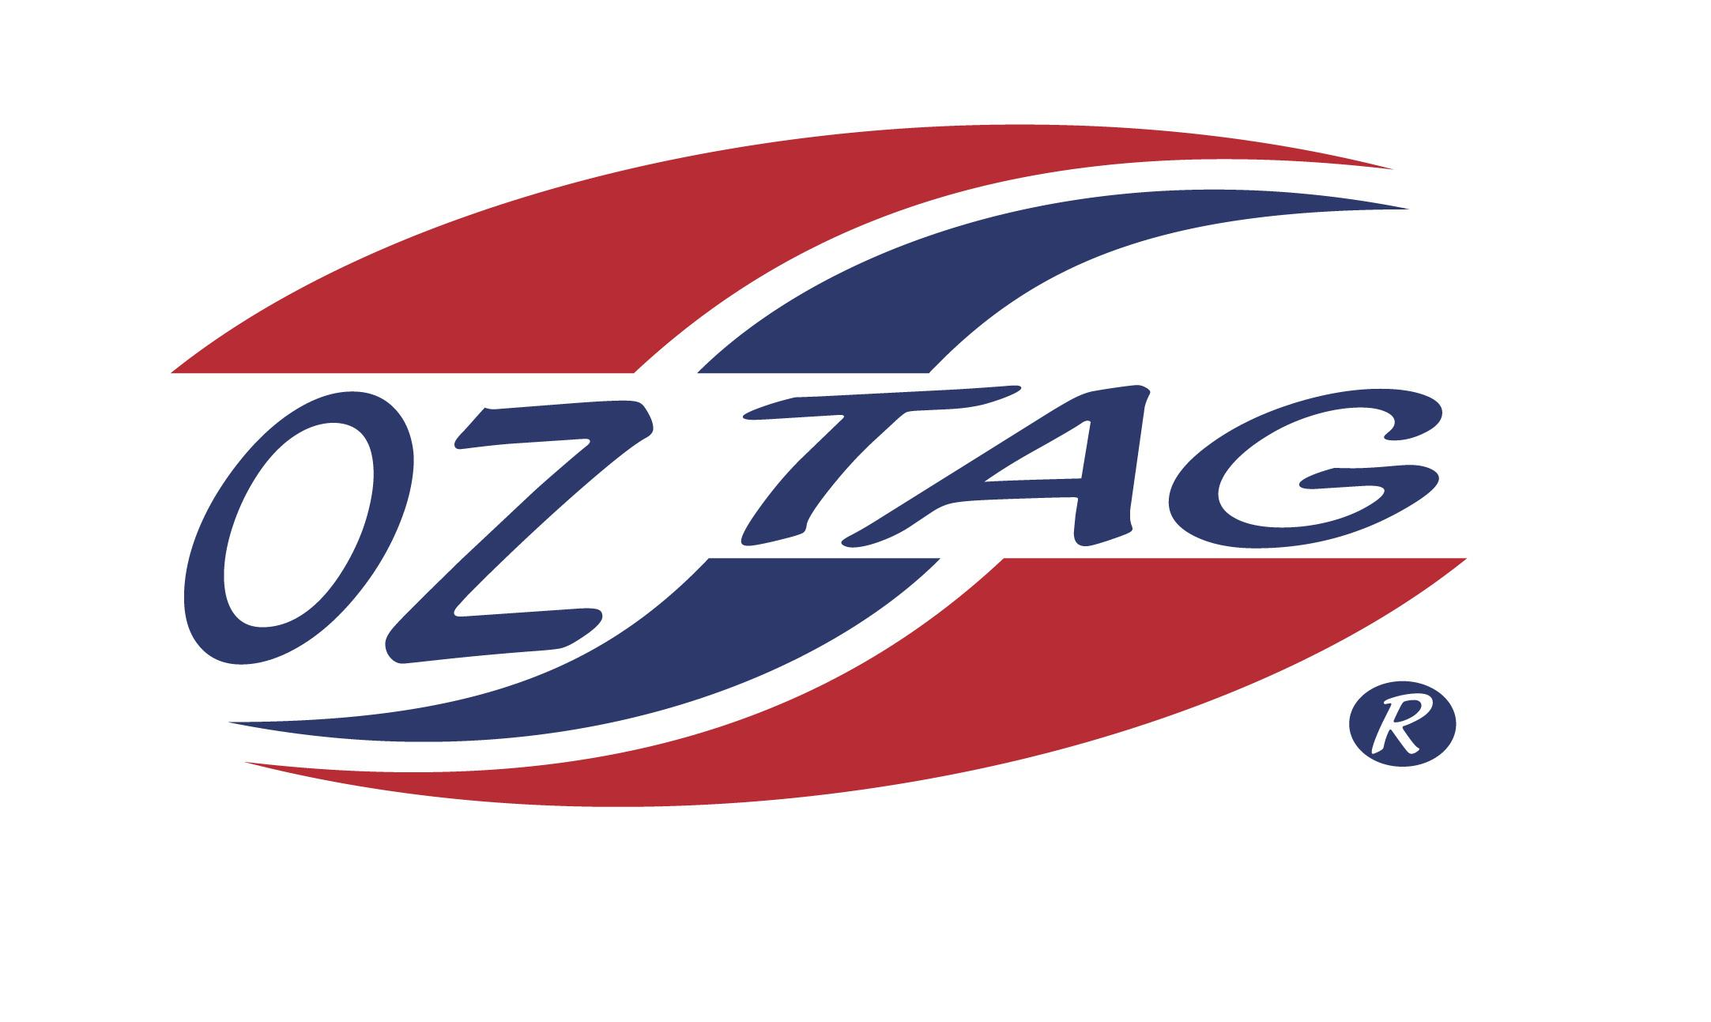
BOYS 12’S

Coach: Stephen Crawford Phone:
Email:
Manager: Roxanne McDonald Phone: 0416187980
Email: threeboysonegirl1982@gmail.com

Congratulations to the following players selected in the East Hills Boys 12’s team to play at the 2021 NSW Junior State Cup – Feb 12 – 14, 2021 - Coffs Harbour
- Please contact your coach to accept your position in the team and confirm your availability
- Tournament entry is $90 and payable now to your team manager or directly into the East Hills Junior Oztag Account – put your name as the reference
- Uniform is the same as last year – please let your manager know your sizes

NAME | TEAM
CALEB MITCHELL | YEAH THE BOYS
JAKE DODD | YEAH THE BOYS
DYLAN THOMPSON | ELECTRIFYING
ASHTON MCDONALD | MILPY BOYS
KYLE EBBS | MILPY BOYS
TYSON KING | MILPY BOYS
JAI CONLAN | NINJAS UP
JACKSON VAJDEVSKI | YEAH THE BOYS
XAVIUS WILSON | YEAH THE BOYS
AFA SUA | YEAH THE BOYS
OSCAR HOOPER | FLYING FOXES
TODD WARDMAN | NINJAS UP
BLAKE PETROVKSI | THE TAGGERS
MICHAEL CONDOLUCI | SAINTS 12’S

