2021 N.S.W JUNIOR STATE CUP

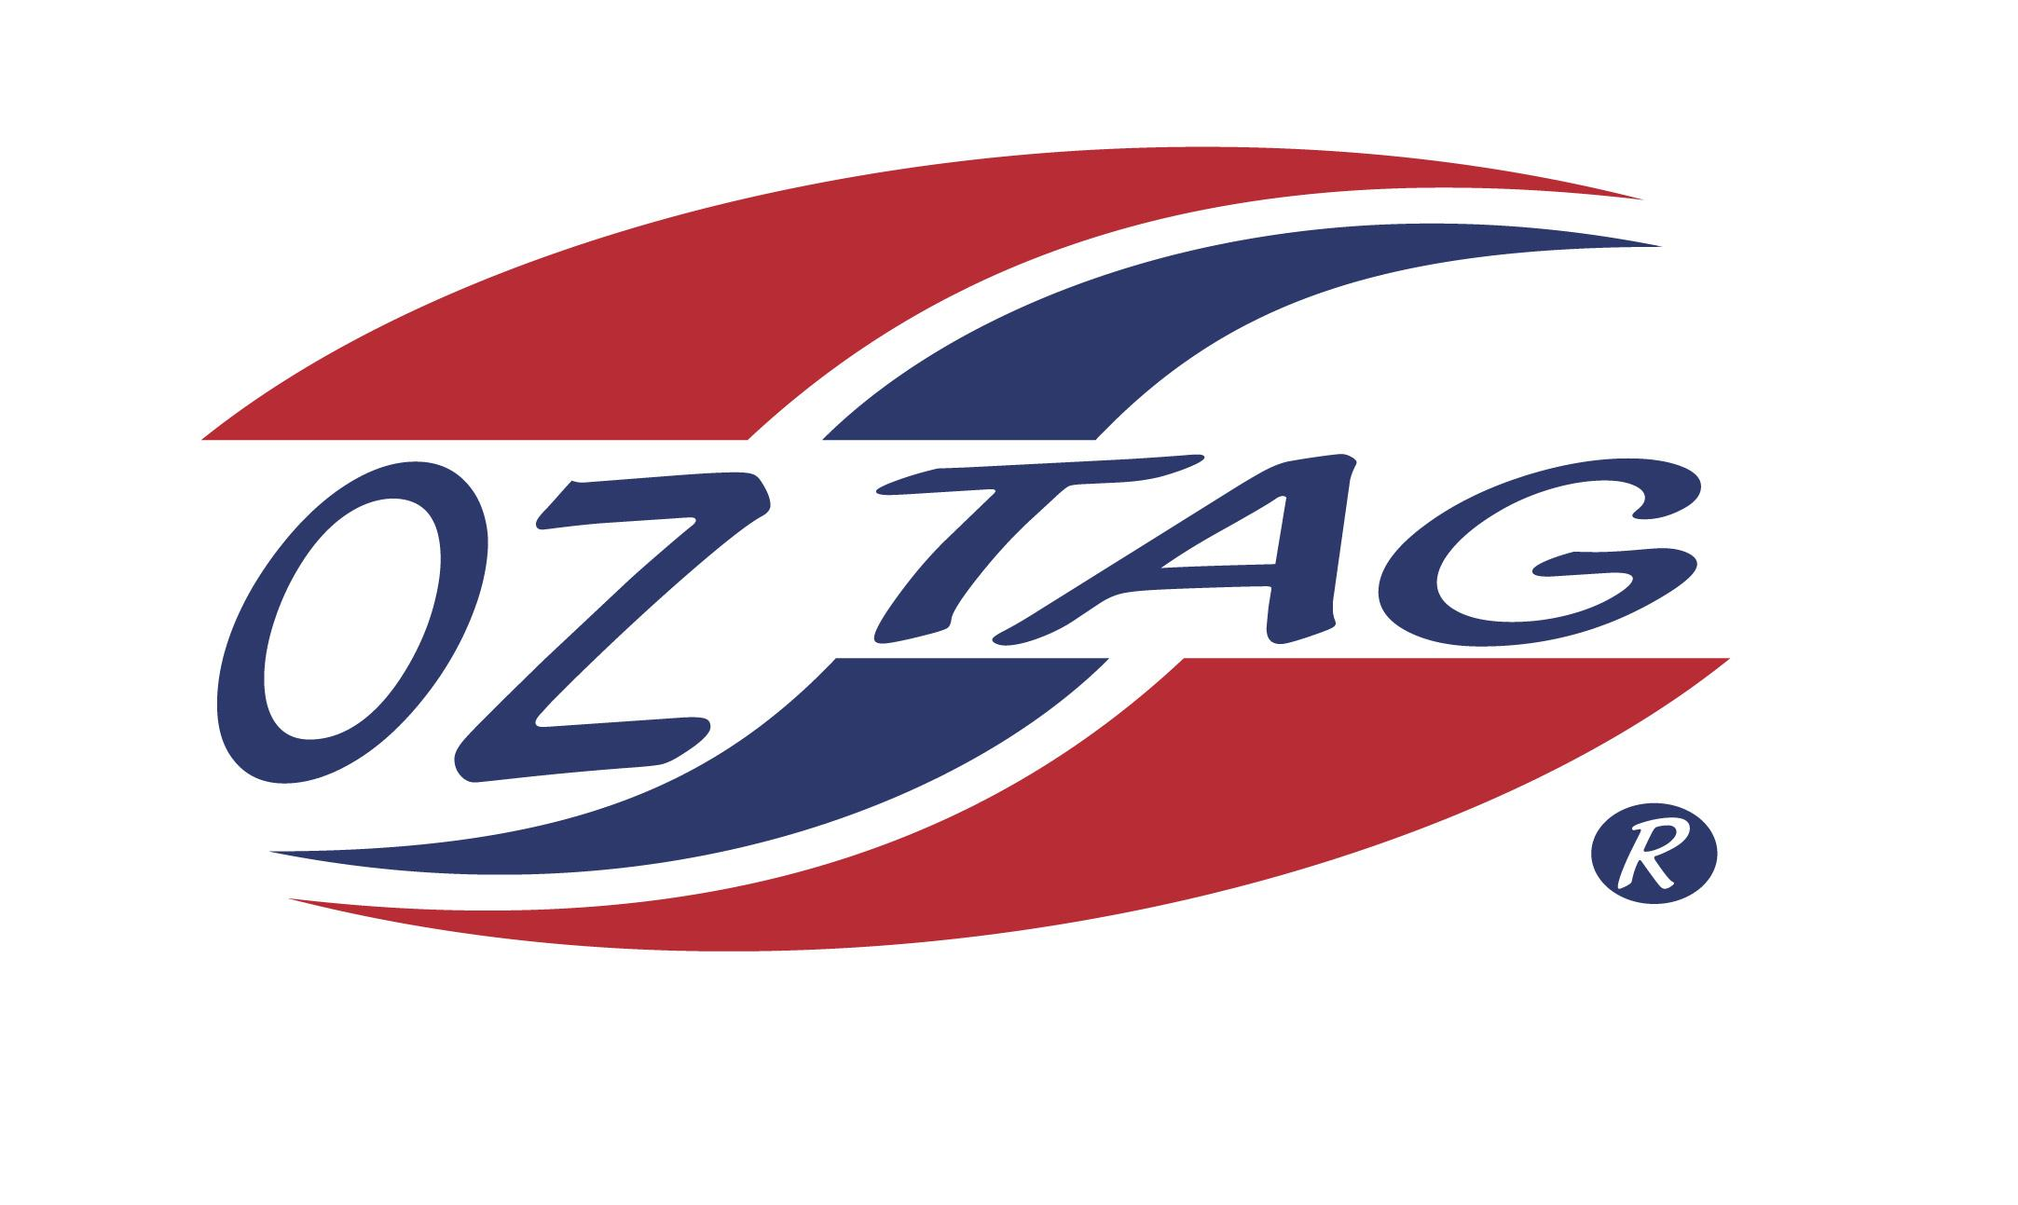
BOYS 11’S

Coach: David Curtis Phone: 0416197552
Email: davidjcurtis1@gmail.com
Manager: Todd Heslehurst Phone: 0413258303
Email: todd@saltcollective.com

Congratulations to the following players selected in the East Hills Boys 11’s team to play at the 2021 NSW Junior State Cup – Feb 26 – 28, 2021 - The Crest, Bass Hill
- Please contact your coach to accept your position in the team and confirm your availability
- Tournament entry is $90 and payable now to your team manager or directly into the East Hills Junior Oztag Account – put your name as the reference
Uniform is the same as last year – please let your manager know your sizes
- Training will start 22nd Nov

NAME | TEAM
LUKE CURTIS | JUNIOR JETS
HARRY HESLEHURST | JUNIOR JETS
JACK BRANNOCK | JUNIOR JETS
ZANE BRANNOCK | JUNIOR JETS
DAMON BEARD | RED BULLETS
CALLUM CLASPER | RED BULLETS
LOGAN TOWERS | CASHED
GIBSON TAKU | CASHED
PATRICK PASSARELLI | WILDCATS
DAIN CHRISTIANSEN | WILDCATS
JARRYD TRICKER | JUNIOR JETS
COOPER GILLARD | JUNIOR JETS
MASON MALLIA | JUNIOR JETS
FLYNN MANU’A | JUNIOR JETS
DONTAE SIOFELE | JUNIOR JETS
CALI MOON | RAGING RHINOS

